TOC – LAB PROGRAMS

1.Design a DFA which accepts the strings bcaaaa , bc ,c.

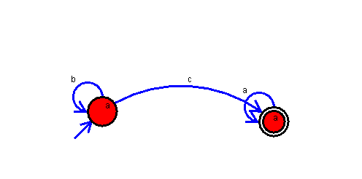

2.Design NFA to accept ‘aaaa’ string.

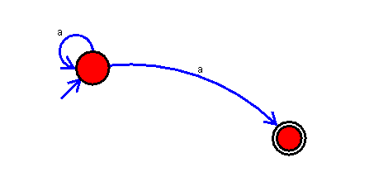

3. Design DFA using simulator to accept the input string “a” ,”ac”,and ”bac”.

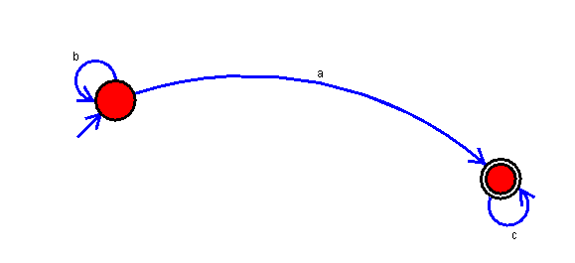

4.Design DFA to accept all strings with even number of a’s.

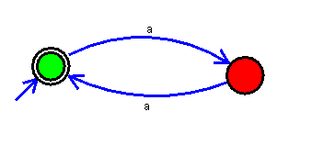

5.Design DFA to accept all strings with odd number of a’s.

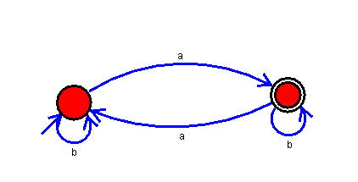

6.Design DFA which accepts all strings which ends with ‘ab’ string

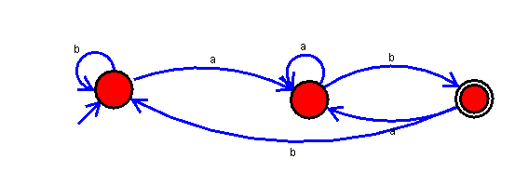

7.Design DFA which accepts all strings which has ‘ab’ as a substring.

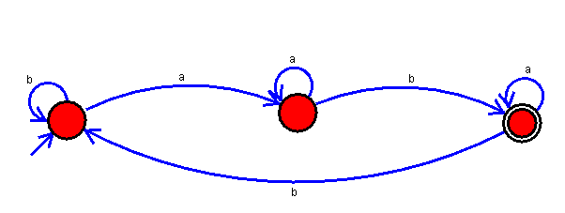

8.Design DFA to accept strings starts with a or b over {a,b}.

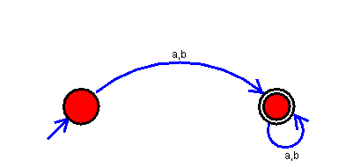

9.Design DFA to accept the strings ‘a’, ‘ac’ and ‘bac’.

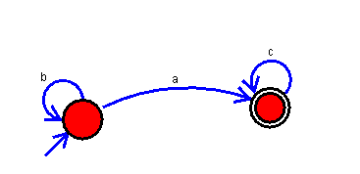

10.Design NFA to accept any number of a’s over input {a,b}

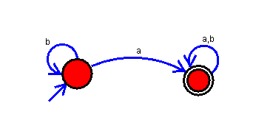

11.Design DFA to accept string having ‘abc’ as substring.

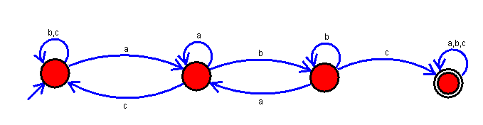

12.Design DFA to accept even number of c’s over {a,b,c}.

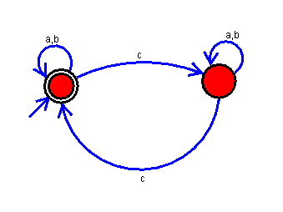

13.Design DFA to accept strings which ends with ‘”abc” over {a ,b c}.

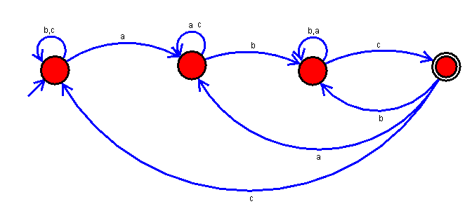

14.Design NFA to accept any number of b’s over {a, b}.

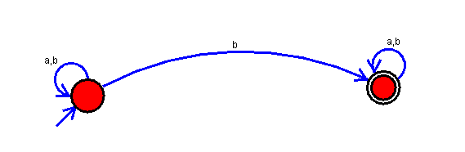

15.Design NFA to accept strings with “bbc” , “c” , “bcaaa”.

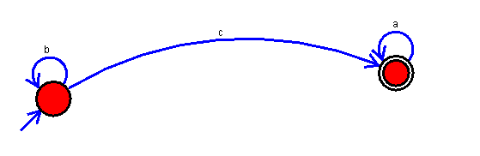

16.Design NFA to accept strings that starts with a and end with b over {a , b}.

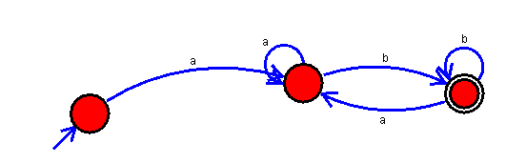

17.Design NFA to accept strings that start and end with different symbols over {a ,b}.

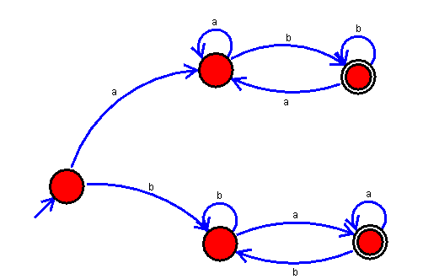

18.Design DFA to accept all strings in which a’s always appear tripled over {a, b}.

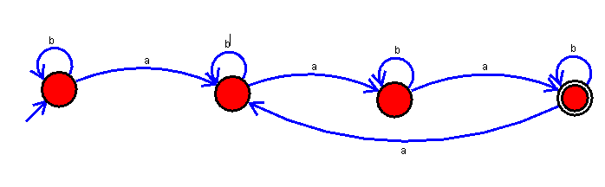

19.Design PDA to accept all strings which comes under this language – a^nb^n.

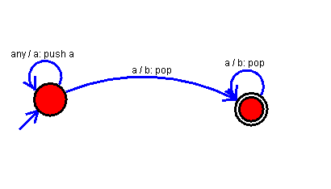\

20.Design PDA to accept all strings which comes under this language – a^nb^2n.

